**NATIONAL UNIVERSITY OF COMPUTER AND EMERGING SCIENCES**

**PROGRAM: SOFTWARE ENGINEERING**



***WEB ENGINEERING LAB***

**LAB TASK 03**

**SUBMITTED BY:**

**Name: Ahmed Ali**

**Roll No: 22P-9318**

**Section: BS(SE)-6B**

**INSTRUCTOR NAME: Sir Zakria**

**A DEPARTMENT OF COMPUTER SCIENCE**

**CODE OF QUESTION 1:**

***<!DOCTYPE html>***

***<html>***

***<head>***

***<title>Lab Task 3</title>***

***<style>***

***body***

***{***

***font-family: Arial, sans-serif;***

***margin: 0;***

***padding: 0;***

***background-color: white;***

***}***

***.container***

***{***

***font-size: 20px;***

***width: 80%;***

***margin: 0 auto;***

***}***

***header***

***{***

***background-color: white;***

***color: purple;***

***text-align: left;***

***padding: 15px;***

***position: relative;***

***}***

***.search-box***

***{***

***position: absolute;***

***top: 25px;***

***right: 20px;***

***background: linear-gradient(to bottom, #d3eb93, #aae435);***

***padding: 15px;***

***border-radius: 5px;***

***}***

***.search-box input***

***{***

***padding: 8px;***

***border-radius: 3px;***

***}***

***.search-box button***

***{***

***background-color: purple;***

***color: white;***

***padding: 8px 12px;***

***border-radius: 4px;***

***cursor: pointer;***

***}***

***.search-box button:hover***

***{***

***background-color: #5a005a;***

***}***

***nav***

***{***

***background: linear-gradient(to bottom, #edeb62, #dddb32);***

***padding: 10px;***

***text-align: center;***

***margin-bottom: 40px;***

***}***

***nav ul***

***{***

***padding: 0;***

***}***

***nav ul li***

***{***

***display: inline;***

***margin: 12px 15px;***

***font-weight: bold;***

***}***

***.intro***

***{***

***background: linear-gradient(to bottom, #d9ec9b, #b5e74a);***

***padding: 50px;***

***text-align: left;***

***margin-bottom: 40px;***

***font-family:times new roman;***

***font-size: 30px;***

***}***

***p***

***{***

***font-size: 30px;***

***}***

***.content***

***{***

***width: 100%;***

***overflow: hidden; /*clear floated elements*/***

***}***

***.web-development, .course***

***{***

***width: 48%; /*each section takes half the width*/***

***float: left; /*position them side by side*/***

***padding: 15px;***

***background: white;***

***border: 2px solid dimgrey;***

***border-radius: 10px;***

***margin-left: 15px;***

***box-sizing: border-box; /*prevents padding from affecting width*/***

***}***

***h3***

***{***

***color: purple;***

***font-weight: bold;***

***}***

***ul***

***{***

***list-style-type: none;***

***padding: 0;***

***}***

***.web-development ul li::before***

***{***

***content: "❌ ";***

***color: red;***

***}***

***.course ul li::before***

***{***

***content: "✔ ";***

***color: green;***

***font-size: 20px;***

***}***

***ul li***

***{***

***padding: 5px;***

***font-size: 16px;***

***}***

***footer***

***{***

***background-color: orange;***

***color: white;***

***text-align: center;***

***padding: 15px;***

***font-size: 18px;***

***font-weight: bold;***

***margin: 0 auto;***

***margin-top: 40px;***

***width: 80%;***

***}***

***</style>***

***</head>***

***<body>***

***<div class="container">***

***<header>***

***<h1>Coding is Poetry</h1>***

***<div class="search-box">***

***<input type="text" placeholder="Search the box">***

***<button>Search the box</button>***

***</div>***

***</header>***

***<nav>***

***<ul>***

***<li>HOME</li>***

***<li>WEB DEVELOPMENT</li>***

***<li>DESKTOP LEARNING</li>***

***<li>REGISTRATION</li>***

***<li>CONTACT US</li>***

***</ul>***

***</nav>***

***<section class="intro">***

***<h1>Want to Learn Coding?</h1>***

***<p>***

***If you are interested in learning programming and want to fulfill your dreams in the field of programming,***

***then you are at the best place. The Computer Software Engineering Department at UET Mardan can polish you***

***and will enhance your programming skills up to the mark. Welcome to the club!***

***</p>***

***</section>***

***<section class="content">***

***<div class="web-development">***

***<h3>Web Development:</h3>***

***<ul>***

***<li>Hyper Text Markup Language</li>***

***<li>Cascading Style Sheet</li>***

***<li>JavaScript</li>***

***<li>Hypertext Preprocessor (PHP)</li>***

***<li>Bootstrap</li>***

***<li>WordPress</li>***

***<li>LARAVEL PHP Framework</li>***

***<li>Angular Technology</li>***

***<li>JQuery</li>***

***<li>AJAX</li>***

***<li>Mean Stack</li>***

***<li>MySQL</li>***

***</ul>***

***</div>***

***<div class="course">***

***<h3>More Options:</h3>***

***<ul>***

***<li>C Programming</li>***

***<li>Object Oriented Programming</li>***

***<li>Microsoft Visual Basic</li>***

***<li>C#</li>***

***<li>JAVA</li>***

***<li>Python</li>***

***</ul>***

***</div>***

***</section>***

***</div>***

***<footer>***

***Ahmed_22p-9318_BS(SE)-6B_Web-Eng.***

***</footer>***

***</body>***

***</html>***

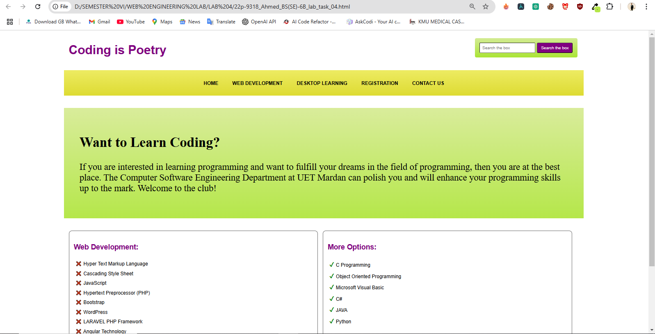**SCREENSHOT: OUTPUT OF Q1**

